- Welcome page

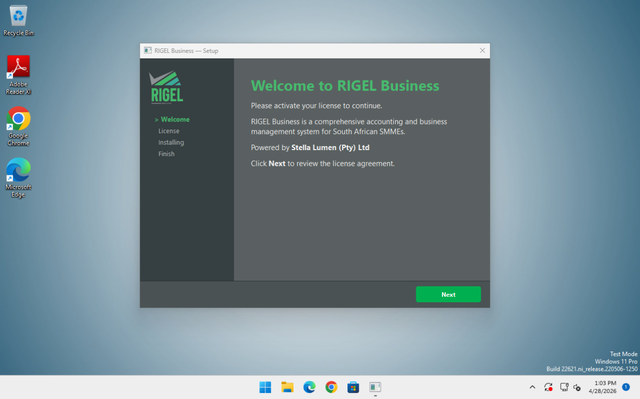

- License

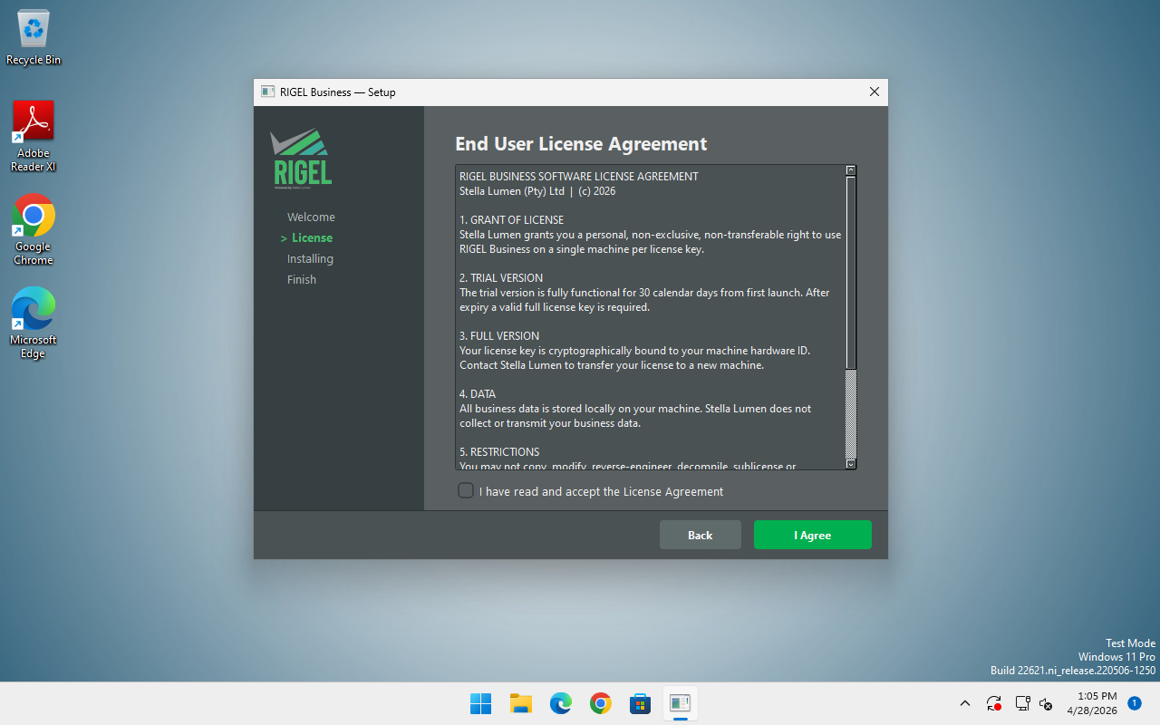

- Installing - needs to be regenerated

- Finish - needs to be regenerated

- Launch Rigel - needs to be regenerated

- License Activation Page

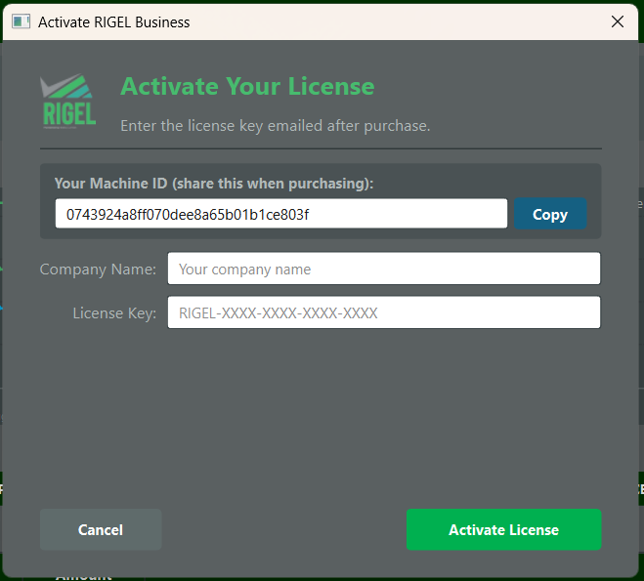

- Landing Page

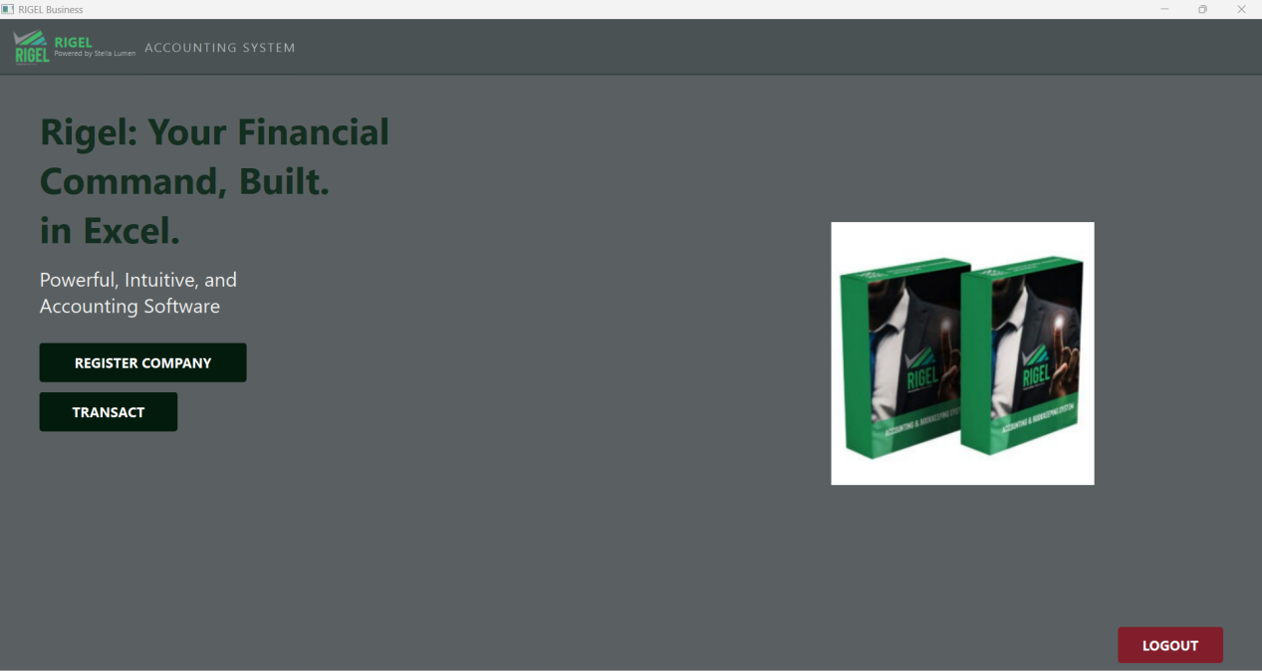

- Index

